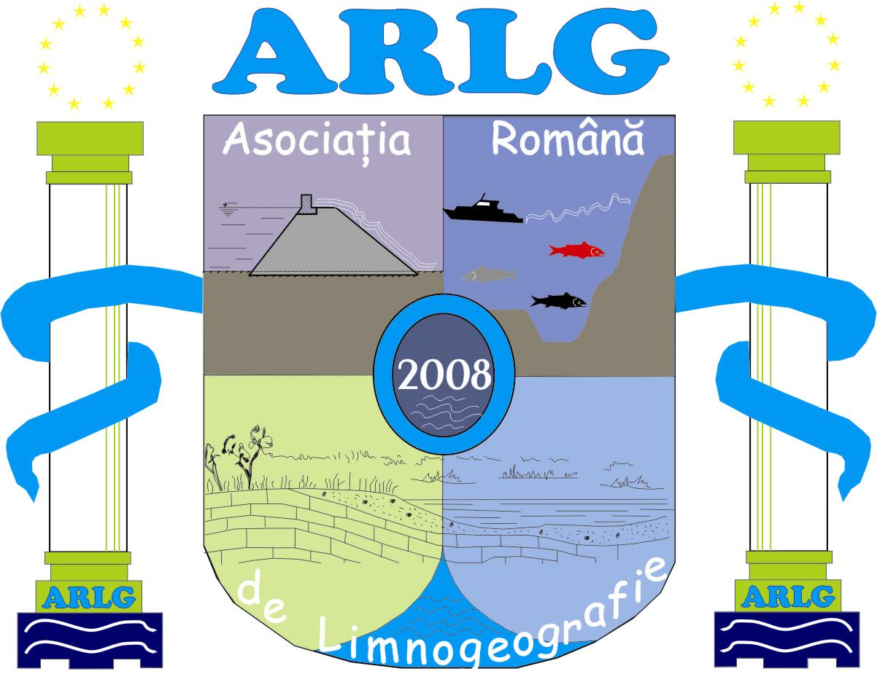



Valahia University of Târgovişte Romanian Limnogeographical Association Institute of Geography Bucharest
www.valahia.ro www.limnology.ro

5th International Conference
Geography, Environment and GIS
for students and young researchers
Targoviste, Romania, May 17-19, 2018
Official Conference website is:
http://www.limnology.ro/geg2018.html
Please complete this form and return by E-mail latest until March 4, 2018.
• e-mail: geg_conference@limnology.ro

Registration
Delegate | Mr. |  | Ms.
Delegate | Student | MSc | PhDs | PhD & PostDocs (<35 y)
Full Familiy name
Full First name
Company/University/Institution
Address
City
Postal Code
Country
Phone
Fax
E-mail

Type of presentation:
Oral | Poster

Themes and Topics
A. Geography
B. Environment
C. GIS

Abstract submission (Abstract is a part of registration form)
All abstracts must be written in English with up to 800 words, including the objectives, main results, and conclusions. No graphs, tables, and references be included
Title
Author(s)
University/Company/Institution
E-mail contact
Abstract (max. 800 words)
Keywords (max. 6)
Professor coord. (only for students and MSc)
Name and email

Field trip: Yes  No 

